**Dharmsinh Desai University, Nadiad**

**Department of Information Technology**

**Advanced Java Technology, IT619**

**B.Tech. IT, Sem: VI**

**Experiment – 06**

**Submitted By**

**Roll No.:IT076**

**Name: Dishant Modh**

**Aim:**  Create a JavaBean to store information about person. The details of person (person

name, person age, person height, etc.) are stored in person database table. After the

person is authenticated, his/her personal details are transferred from the database table

(person) to JavaBean (Person) and the details are displayed in proper format using this

Person JavaBean. The JavaBean is stored in session scope.

**Code:**

**🡪Persondetail.jsp**

<%@page contentType="text/html" pageEncoding="UTF-8"%>

<jsp:useBean id="personBean" class="com.Personbean" scope="request"/>

<!DOCTYPE html>

<html>

<head>

<title>Person Details</title>

<meta http-equiv="Content-type" content="text/html; charset=UTF-8">

</head>

<body style="background-color: powderblue">

<h2>Get Person Details</h2>

<form action="Process.jsp" method="post" name="formregistration">

<table>

<tr>

<td>USERID:</td>

<td><input type="text" name="uid" value="<%=personBean.getUserName()%>"></td>

</tr>

<tr>

<td>PASSWORD:</td>

<td><input type="password" name="pass" value="<%=personBean.getPassword()%>"></td>

</tr>

<tr>

<td><input type="submit" value = "Get Details"></td>

</tr>

</table>

</form>

</body>

</html>

**🡪Process.jsp**

<%@page language="java" import="java.util.*" %>

<jsp:useBean id="personBean" class="com.Personbean" scope="request">

<jsp:setProperty name="personBean" property="*"/>

</jsp:useBean>

<%

if(personBean.validate(request.getParameter("uid"),request.getParameter("pass"))) {

%>

<jsp:forward page="Display.jsp"/>

<%

} else {

%>

<jsp:forward page="Persondetail.jsp"/>

<%

}

%>

**🡪Display.jsp**

<%@page contentType="text/html" pageEncoding="UTF-8"%>

<!DOCTYPE html>

<jsp:useBean id="personBean" class="com.Personbean" scope="request"/>

<html>

<head>

<meta http-equiv="Content-Type" content="text/html; charset=UTF-8">

<title>Person Details</title>

</head>

<body style="background-color: powderblue">

<h2>Person Details</h2>

<form>

<table>

<tr>

<td>USER NAME:</td>

<td><jsp:getProperty name="personBean" property="name"/></td>

</tr>

<tr>

<td>AGE:</td>

<td><jsp:getProperty name="personBean" property="age"/></td>

</tr>

<tr>

<td>HEIGHT:</td>

<td><jsp:getProperty name="personBean" property="height"/></td>

</tr>

</table>

</form>

</body>

</html>

**🡪Personbean.java**

package com;

import java.util.*;

import java.beans.*;

public class Personbean implements java.io.Serializable{

private String name ="";

private String userName = "";

private String password = "";

private int age;

private int height;

private Hashtable error;

Personservlet user;

public Personbean() {

}

public boolean validate(String u,String p)

{

boolean allOk = true;

if(u.equals(""))

{

error.put("userName","Enter the User Name");

userName="";

allOk=false;

}

if(p.equals(""))

{

error.put("password1","Enter a valid password");

password="";

allOk=false;

}

//System.out.print("hello");

user=new Personservlet(u, p);

allOk=user.checkUser();

if(allOk)

{

user.getUserData();

System.out.println("=====================================");

name=user.Name;

age=user.age;

height=user.height;

}

System.out.println("$$$$$$$$$$$$$$$$$$$$$$$$$$"+allOk);

return allOk;

}

public String getErrorMsg(String s)

{

String errorMsg=(String)error.get(s.trim());

return (errorMsg==null)?"":errorMsg;

}

public void setErrors(String key,String msg)

{

error.put(key,msg);

}

public String getName() {

return name;

}

public void setName(String name) {

this.name = name;

}

public int getAge() {

return age;

}

public void setAge(int age) {

this.age = age;

}

public int getHeight() {

return height;

}

public void setHeight(int height) {

this.height = height;

}

public String getUserName() {

return userName;

}

public void setUserName(String userName) {

this.userName = userName;

}

public String getPassword() {

return password;

}

public void setPassword(String password) {

this.password = password;

}

public Hashtable getError() {

return error;

}

public void setError(Hashtable error) {

this.error = error;

}

}

**🡪Servlet Class**

**Personservlet.java**

package com;

import java.sql.Connection;

import java.sql.DriverManager;

import java.sql.PreparedStatement;

import java.sql.Statement;

import java.sql.ResultSet;

public class Personservlet {

Connection db;

String SelectQuery;

PreparedStatement ps;

public String userName,password,Name;

public int age,height;

public Personservlet(String userName,String password1)

{

try

{

Class.forName("org.apache.derby.jdbc.ClientDriver");

this.userName=userName;

this.password=password1;

}

catch(Exception e)

{

System.out.println("Phase 1: "+e);

}

}

public boolean checkUser()

{

boolean check=false;

System.out.println("-----------------"+userName+"-------"+password);

try

{

db=DriverManager.getConnection("jdbc:derby://localhost:1527/Registration","dmx","dmx");

ps=db.prepareStatement("SELECT * from person where uname=? and pass=?");

ps.setString(1,userName.trim());

ps.setString(2,password.trim());

ResultSet Res=ps.executeQuery();

check=Res.next();

ps.close();

db.close();

}

catch(Exception e)

{

System.out.println("Phase 2: "+e);

}

return check;

}

public void getUserData()

{

try

{

db=DriverManager.getConnection("jdbc:derby://localhost:1527/Registration","dmx","dmx");

ps=db.prepareStatement("SELECT * from person where uname=? and pass=?");

ps.setString(1,userName.trim());

ps.setString(2,password.trim());

ResultSet Res=ps.executeQuery();

if(Res.next())

{

Name=Res.getString("name");

age=Res.getInt("age");

height=Res.getInt("height");

System.out.println("===="+Name+"-"+age+"-"+height);

}

ps.close();

db.close();

}

catch(Exception e)

{

System.out.println("Phase 3: "+e);}

}

}

**🡪web.xml file: -**

<?xml version="1.0" encoding="UTF-8"?>

<web-app version="3.1" xmlns="http://xmlns.jcp.org/xml/ns/javaee" xmlns:xsi="http://www.w3.org/2001/XMLSchema-instance" xsi:schemaLocation="http://xmlns.jcp.org/xml/ns/javaee http://xmlns.jcp.org/xml/ns/javaee/web-app_3_1.xsd">

<servlet>

<servlet-name>Personservlet</servlet-name>

<servlet-class>com.Personservlet</servlet-class>

</servlet>

<servlet-mapping>

<servlet-name>Personservlet</servlet-name>

<url-pattern>/Personservlet</url-pattern>

</servlet-mapping>

<session-config>

<session-timeout>

30

</session-timeout>

</session-config>

</web-app>

**Input/Output:**

1. **Login form**

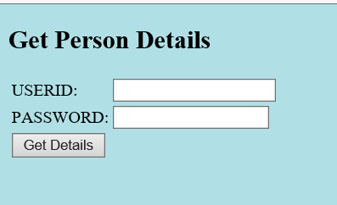

1. **Enter the Valid Data**

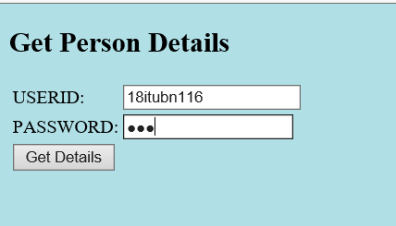

1. **After clicking on Get Details**

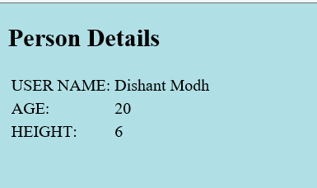

1. **Entering the Invalid data**

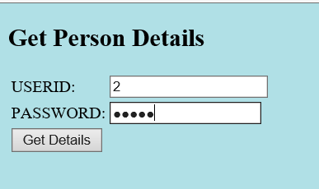

**Then it will redirect to the login page**



1. **Database: -**

